Hello World Application on Cloud Foundary (Pivotal)

1. Made a Hello world application in Python language and stored it in the below GitHub repository.

<https://github.com/lavleenbhat/cloudarchitecture2017.git>

**Application:** [**cloudarchitecture2017**](https://github.com/lavleenbhat/cloudarchitecture2017)/**firstapp/helloworld.py**

1. Created an account on Pivotal Cloud Foundary provided
2. Created the application using Python.
3. 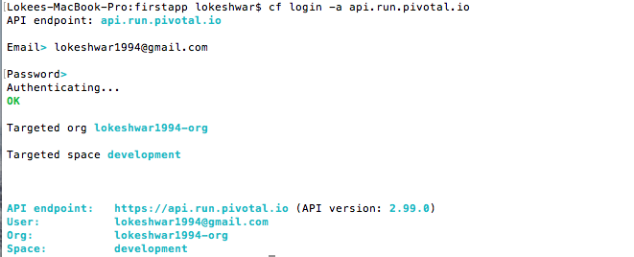logon to the cloud foundary using the following commands in the Terminal
4. Deployed the application to the Cloud Foundary using **cf push flask-firstapp-ih**

Project: Cloud Architecture

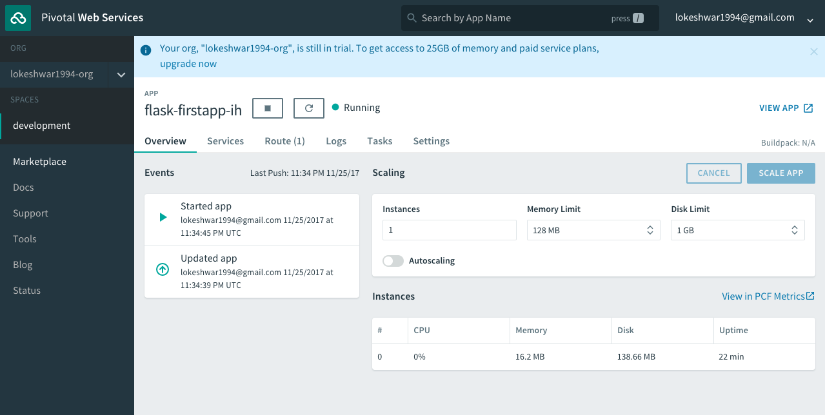Application after deployment:

The application was deployed successfully and got the application running as below

